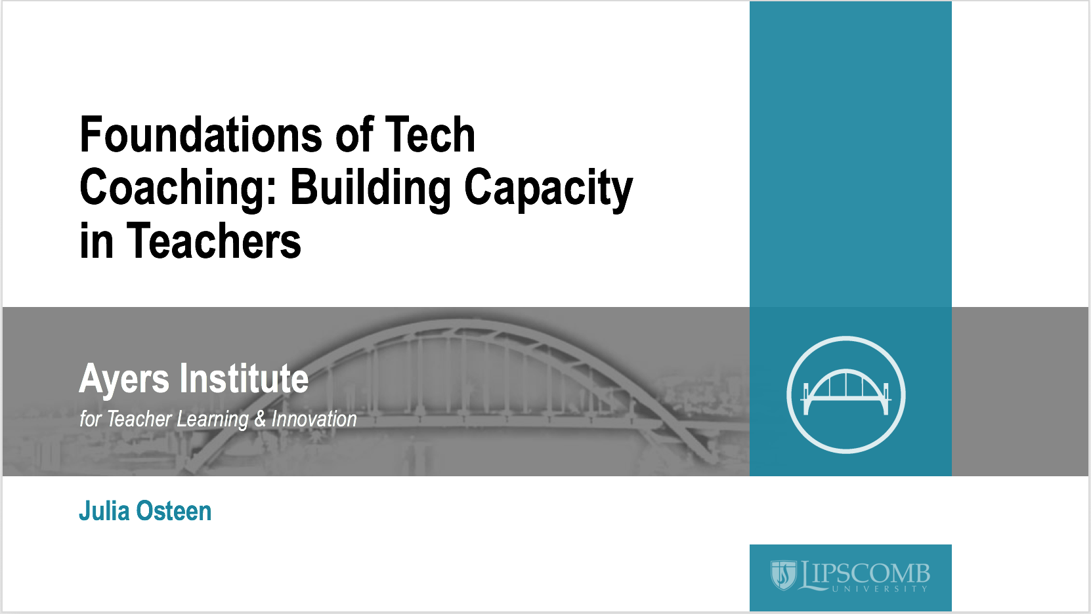
Presenter: Julia Osteen, Technology Integration Specialist, Ayers Institute for Teacher Learning & Innovation at Lipscomb University, julia.osteen@lipscomb.edu

Session description: How do Technology Coaches have the most influence in their schools and district? They build capacity in teachers! In this session we will explore the ISTE Standards for Technology Coaches, define coaching, consider what coaching is and is not and discuss the importance of approaching situations and people with a coaching mindset. Session participants will leave with a vision for how showing up first as “coach” can positively impact their work.
Session link: https://edutoolbox.org/node/487

Session notes:
Key points:

The Coaching Mindset
___________________________________________________________________________________________________________________________________________________________________________________________________________________________________________________________________________________________________________________________________________________________________________________________________________________________________________________

What is a coach?
Not an enforcer
Not a fixer
Not a therapist
Not a spy
Not a consultant

ISTE Standards for Coaches
To improve technology coaching performance
To improve technology integration in schools
Who is a technology coach?
Six standards
Rubrics and explanations

Foundational Skill: Committed Listening
Unproductive patterns of listening
Listen for vs. listen to

Reflection

Session resources:
Poll Everywhere – http://pollev.com/josteen

ISTE Standards for Coaches - https://www.iste.org/standards/for-coaches

Effective Digital Learning Environments - https://www.iste.org/resources/product?id=3732

Ayers Institute Instructional Coaching Academy: Skills Development - https://tinyurl.com/july2018coachingacademy

Ayers Institute Instructional Coaching Academy: Models and Practices - https://tinyurl.com/sept2018coachingacademy

Lipscomb University College of Education Graduate Programs - https://www.lipscomb.edu/education/graduate-programs

References:

Aguilar, E. (2005). The Art of Coaching: Effective strategies for school transformation. San Francisco: Jossey-Bass.

Kee, K., & Anderson, K. (2010). RESULTS Coaching: The new essential for school leaders. Thousand Oaks, CA: SAGE Publications.

Williamson, J. (2015). Effective digital learning environments: Your guide to the ISTE standards for coaches. International Society for Technology in Education

