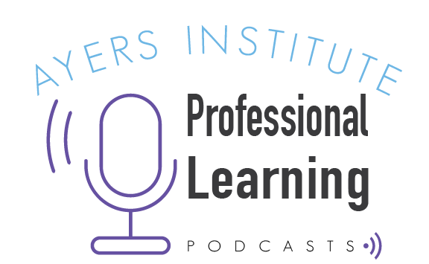
Podcast Professional Learning

Overview
Every day, educators look for professional learning options that are both relevant and on a schedule that doesn’t encroach on their other responsibilities. Educators often don’t have large pockets of time to give to professional learning. Podcasts are a great way to receive “just in time” professional learning that can benefit you individually and spark conversations within your community of practice.

This graphic organizer will help you turn podcast listening into documented podcast learning. You can use this tool for individual professional growth or, even better, you can share your learning with others.

Participant identification:
Full Name | School/Organization | Start Date

1) Select
Choose a podcast episode to listen to for the purpose of professional growth.

Podcast title:
Podcast website (URL):
Episode identifier:
A podcast episode might be identified by an episode title, an episode number, or an episode release date.

Why chosen:
A brief explanation of why you selected this podcast and episode. What connection or relevance to did you expect? What did you hope to learn by listening to this podcast episode?

2) Listen
As you listen to the podcast episode, make note of the speakers’ main points, recommended resources, and suggested actions. Also record any questions or ideas that come to your mind as you listen to the material presented.

Key points:
Summarize the most important pieces of information, resources, or questions that were shared during the podcast episode.

3) Reflect
Based on the podcast material, form several questions that are related to the topic and are specific to your personal practice or to the school/district/organization in which you work.

 | Who to ask? | Question:
Question #1
Question #2
Question #3

4) Explore
Select one or more of your reflection questions and then ask appropriate contacts for answers, suggestions, or input.

Findings:
What did you learn as a result of asking questions or seeking input related to some of your reflection questions?

5) Apply
What will you read, search, try, and/or assess as a result of your podcast learning and your exploration findings?

Action plan:
Timeframe:
Desired outcome:

6) Share
Present what you have learned through podcast listening, reflection, exploration, and application within a community of practice (e.g. a Professional Learning Community (PLC) or a Professional Learning Network (PLN)). Discuss with your peers how these ideas and resources can strengthen your professional practice and improve student outcomes?

Where Shared (e.g. 6th Grade PLC meeting) | Date Shared

